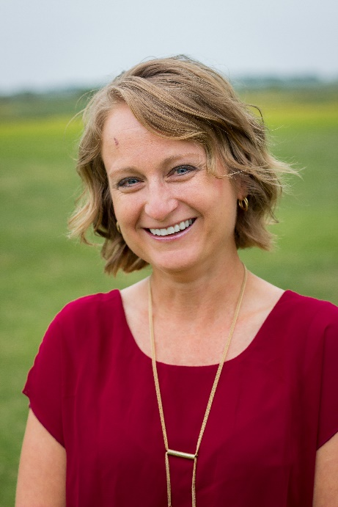

Jamie Hoos – Women’s Ministry Leader and Speaker
Jamie is a ministry leader passionate about the work of Christ in the local church. She has taught the Bible for over a decade and recently began dabbling in both blogging and writing her own curriculum for women’s studies. Out of the overflow of God’s work in her life, Jamie challenges women to place their hope in God as He purposes to use them in the lives of their families, friends, church and the community. She holds a BA in Elementary Education and a Graduate Certificate of Women’s Ministry from the New Orleans Baptist Theological Seminary. She lives with her husband, Andy, and their five children in Green Ridge.

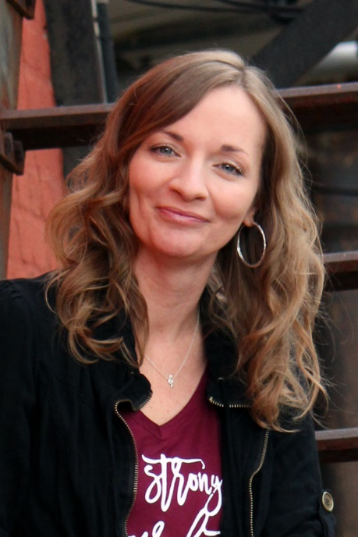
Christy Hoagland – Worship Leader and Recording Artist
Christy is a singer, songwriter, recording artist and worship leader. She has a Certificate in Worship Ministry from Southeastern Baptist Theological Seminary and leads worship in prisons, conferences, celebrate recovery meetings, church events and services, revivals and more. She serves on a prison ministry team “Sing for the King Ministries” with her husband, James, and former inmate and friend, Johnny. They offer worship services to the incarcerated. Christy started writing music in 2016 using God’s Word. She began leading these songs in prisons and at other venues and was overwhelmed at the impact they were making in the lives of offenders and others. Christy and James have been married since 1993 and have two grown sons, Cameron (daughter-in-law, Danii) and Christian (and daughter-in-law, Sydney) and granddaughter, Faye.

